# Investment Insights Dashboard Report

## Introduction

This project analyzes investment preferences, objectives, and behaviors of individuals using Power BI. It involves exploring demographic factors, preferred investment avenues, monitoring frequency, and sources of investment information. The dataset contains various attributes such as age, gender, investment type, savings objectives, monitoring frequency, and investment duration. The main goal is to visualize these insights in an interactive, easy-to-understand dashboard that can help financial advisors, policy makers, and investors make informed decisions.

The report is divided into multiple tasks, each focusing on a specific part of the analysis. These tasks together form a complete view of investment patterns and preferences. Each task section includes a description of what was done, a placeholder for the relevant screenshot, and key insights derived from the visualization.

## Task 1: Overview Statistics and Investment Avenues

### Description:

Display KPIs for average age, total individuals, and average investment values in different avenues.

### Process:

In Power BI, KPI Card visuals were used to display numeric summaries. A bar chart was created to show savings objectives, and a donut chart was used to visualize the distribution of different investment avenues. Data fields were selected from the dataset and formatted appropriately.

### Purpose:

To provide a quick summary of demographic and investment overview to the user.

### Insights:

- Average age: 27.80 years

- Majority saving for Retirement Plans.

- Mutual Funds and Equity are preferred avenues.

## Task 2: Gender-wise Investment Preference

### Description:

Compare the investment values in different avenues between male and female investors.

### Process:

A clustered column chart was used to compare investment types (Mutual Funds, Equity Market, Government Bonds) by gender. KPIs for total male and female investors were added using count functions.

### Purpose:

To understand how gender influences investment preferences.

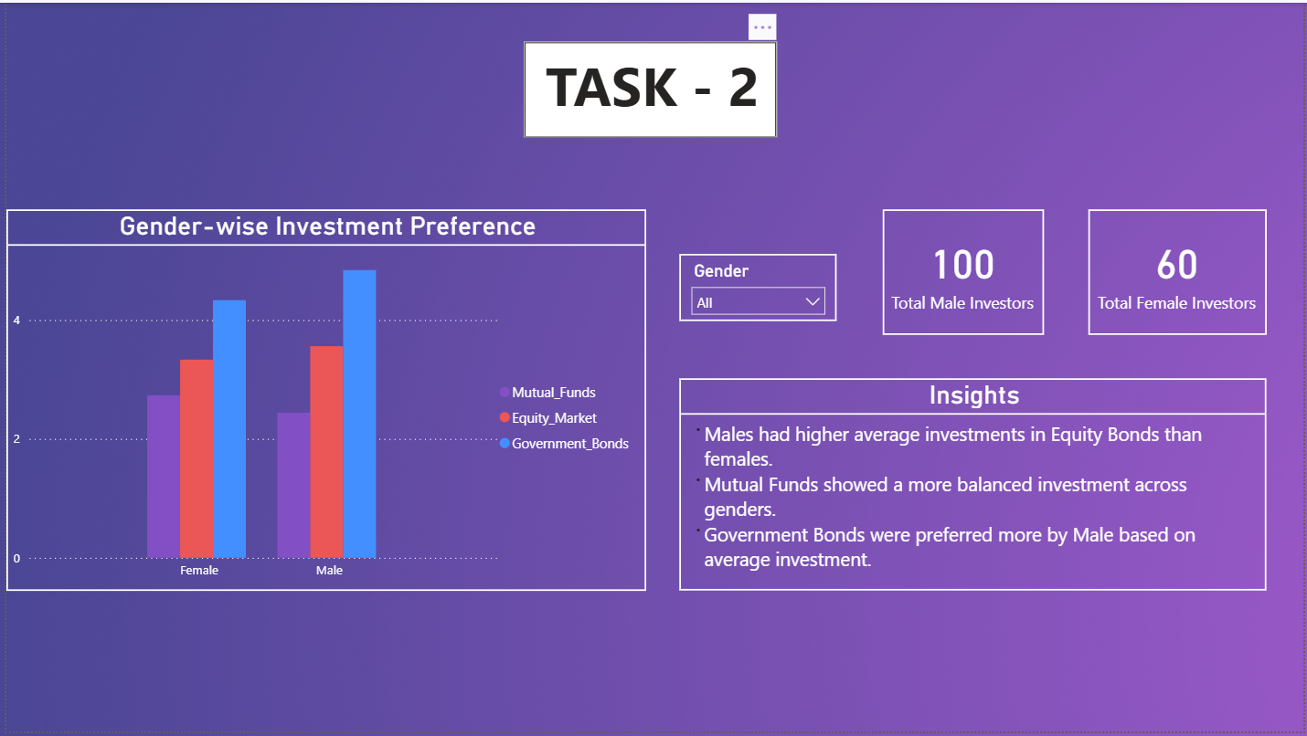

### Insights:

- Males invest more in Equity.

- Mutual Funds are balanced across genders.

- Government Bonds favored slightly by males.

## Task 3: Investment Choices by Saving Objectives

### Description:

Analyze how different saving objectives influence investment choices.

### Process:

A clustered column chart was created showing investment amounts in Equity, Government Bonds, and Mutual Funds for each saving objective. A slicer was added for dynamic filtering.

### Purpose:

To link saving objectives to actual investment decisions.

### Insights:

- Capital Appreciation → Equity

- Retirement → Government Bonds

- Wealth Creation → Mutual Funds

## Task 4: Monitoring Frequency & Duration

### Description:

Analyze how often investors monitor their investments and their preferred investment durations.

### Process:

A donut chart was used to show monitoring frequency. A clustered bar chart displayed the distribution of investment durations, and another clustered column chart compared choices based on monitoring frequency.

### Purpose:

To assess the role of monitoring habits and duration in shaping investment strategies.

### Insights:

- Monthly monitoring is most common.

- Long-term investors prefer Government Bonds.

## Task 5: Reasons for Investment

### Description:

Identify the primary reasons why individuals choose to invest.

### Process:

A donut chart was created using the 'Reason for Investment' field from the dataset to show the percentage distribution.

### Purpose:

To understand investor motivations for choosing certain avenues.

### Insights:

- Capital Appreciation, Assured Returns, and Better Returns are top reasons.

## Task 6: Sources of Investment Information

### Description:

Examine where investors get their information about investments.

### Process:

A bar chart was created to show the preferred sources such as Internet, Financial Advisors, Newspapers, etc.

### Purpose:

To identify the most trusted sources for investment advice.

### Insights:

- Internet is most preferred.

- Newspapers and Financial Advisors are also significant.

## Task 7: Final Dashboard

### Description:

Combine all previous visuals into one unified, interactive dashboard.

### Process:

A dashboard page was created in Power BI, arranging all charts and KPIs from previous tasks. Slicers for Gender, Duration, Savings Objectives, and Monitor Frequency were added for dynamic exploration.

### Purpose:

To provide a complete and interactive view of investment patterns in one place.

### Insights:

- Holistic view of all investment-related patterns.

## Conclusion

The dashboard offers a clear, data-driven overview of investor behavior. By integrating demographic details, objectives, monitoring habits, and information sources, it becomes a powerful decision-making tool for financial institutions and individual investors. The insights derived can guide marketing strategies, policy making, and personalized financial advice.